|  |  |
| --- | --- |
| * Copyright (c) 2008 - 2023, Leopard Imaging Inc. All Rights Reserved. | |
| Overview | |
| This driver is designed for LI-AR0234CS-GMSL-STEREO (Hawk) camera kit with Nvidia Jetson AGX Orin Developer kit.  This driver supports up to four LI-AR0234CS-GMSL2-STEREO cameras.  This driver supports 1920x1200@60fps.  This driver is based on R35.3.1 (Jetpack 5.1.1) | |
| Download link | |
|  | |
| [Platform](https://www.dropbox.com/sh/zz5o7rrh6y7sdnl/AACJhNaRVDru-udgD85k1b4Ma?dl=0) | Camera |
| Nvidia Jetson AGX Orin Developer kit | 1 ~ 2 x LI-AR0234CS-GMSL2-STEREO camera(s) |
| Cable | Adapter/Carrier Board |
| 1 x 4-in-1 Fakra cable  (LI-FCB-4T-1-SS-2M-WP-A0) | 1 x E3653-A03  1 x LI-JTX1-SUB-ADPT |
|  | |

|  |  |  |  |  |  |  |
| --- | --- | --- | --- | --- | --- | --- |
| Revision | | SVN version | Release Date | Author | Tested by | |
| 20210414 | | TBD | 04/14/2021 | Xingxing Gu | Bin Liu | |
| Updates | | | | | | |
| Revision | Description | | | | | Release Date |
| 20210414 | First Release based on R32.5 | | | | | 04/14/2021 |
| 20210511 | Support NVS imu driver | | | | | 05/11/2021 |
| 20210705 | Support autoContect Switch | | | | | 07/05/2021 |
| 20210812 | Support 32.6 | | | | | 08/12/2021 |
| 20210918 | Support NVS | | | | | 09/18/2021 |
| 20220301 | Support 60fps | | | | | 03/01/2022 |
| 20220310 | Support 32.7 JP4.6.1 | | | | | 03/10/2022 |
| 20220316 | Fix the one camera issue | | | | | 03/16/2022 |
| 20220318 | Fix flicker issue | | | | | 03/18/2022 |
| 20220415 | Support JP50 | | | | | 04/15/2022 |
| 20220526 | Support JP50.1 add 960x600@120fps | | | | | 05/26/2022 |
| 20220530 | Support Orin | | | | | 05/30/2022 |
| 20220715 | Support IMU | | | | | 07/15/2022 |
| 20220720 | Support IMU timestamp | | | | | 07/20/2022 |
| 20220822 | Support 35.1 | | | | | 08/22/2022 |
| 20220922 | Fix the ethernet issue when install the ko | | | | | 09/22/2022 |
| 20220927 | Fix the imu issue on Orin | | | | | 09/27/2022 |
| 20221008 | Fix the hawk 60fps issue. | | | | | 10/08/2022 |
| 20221011 | Fix the Xavier issue | | | | | 10/11/2022 |
| 20221028 | Remove second hawk imu interrupt pin | | | | | 10/28/2022 |
| 20230407 | Support 35.3.1 | | | | | 04/07/2023 |
| 20230505 | Support serial number check | | | | | 05/05/2023 |
| Known bugs | | | | | | |
| 1. If you only have one hawk camera, you can only connect on port 1 | | | | | | |

|  |
| --- |
| Setup Procedure 1/2 |
| **Hardware:**  1. Nvidia Jetson AGX Orin Developer Kit x 1  2. E3653-A03 x 1  3. LI-JTX1-SUB-ADPT x 1  4. LI-AR0234CS-GMSL2-STEREO x 1 ~ 4  5. 4-in-1 Fakra cable x 1 (LI-FCB-4T-1-SS-2M-WP-A0)  6. USB 3.0 Type-C cable x 1 (for flashing OS image)  7. Monitor with HDMI cable x 1  8. Keyboard and Mouse (with USB hub) x 1  **Driver installation:**  1. Download the R35.3.1 OS Image (from link below) to your Ubuntu OS on Intel x64 Host PC (we are using Ubuntu 20.04/18.04; virtual machine is fine) and follow the l4t_quick_start_guide to install the Jetpack to Orin.  2. Use the sudo command to copy the tegra234-p3701-0000-p3737-0000.dtb to the /boot/dtb/kernel_ tegra234-p3701-0000-p3737-0000.dtb in your Orin platform, and use the sudo command again to copy the tegra194-p2888-0001-p2822-0000.dtb to the boot/dtb/kernel_tegra194-p2888-0001-p2822-0000.dtb such as the following:  sudo cp tegra234-p3701-0000-p3737-0000.dtb /boot/dtb/kernel_tegra234-p3701-0000-p3737-0000.dtb  sudo cp tegra194-p2888-0001-p2822-0000.dtb /boot/dtb/kernel_tegra194-p2888-0001-p2822-0000.dtb  3. Open a terminal and then use the commands below to remove the existing *. ko files (max96712.ko and nv_ar0234.ko) from the “/lib/modules/5.10.104-tegra/kernel/drivers/media/i2c/” directory first.  sudo rm /lib/modules/5.10.104-tegra/kernel/drivers/media/i2c/max96712.ko  sudo rm /lib/modules/5.10.104-tegra/kernel/drivers/media/i2c/nv_ar0234.ko  sudo rm /lib/modules/5.10.104-tegra/kernel/drivers/iio/imu/bmi088/bmi088.ko  4. Reboot AGX Orin/Xavier kit, and then open a terminal and then perform the below commands.  sudo insmod max96712.ko  sudo insmod nv_ar0234.ko  sudo insmod bmi088.ko  **Note:**  **1. The max96712.ko, nv-ar0234.ko, & bmi088.ko files are included in downloaded Driver’s “Binaries” folder.**  **2. If you restart the Orin system, you must repeat these two commands again before using Argus Software, Gstreamer, or other camera capture applications to stream video images.** |

|  |
| --- |
| Setup Procedure 2/2 |
| 5. Then execute the command below to get live video images output.  nvgstcapture-1.0  **Note:**  **Make sure the first camera is connected to Port 1,**  **then the second camera connected to Port 2, and so on.**  6. Use Ctrl+C to close the video and then copy “camera_overrides.isp” from you downloaded driver’s “Binaries” directory to /var/nvidia/nvcam/settings directory and then use root (sudo) commands to change the file permission and its ownership such as the following:  sudo cp camera_overrides.isp /var/nvidia/nvcam/settings/  sudo chmod 664 /var/nvidia/nvcam/settings/camera_overrides.isp  sudo chown root:root /var/nvidia/nvcam/settings/camera_overrides.isp    7. Try "nvgstcapture-1.0” again. You should be able to see the image with better image quality  nvgstcapture-1.0 |

|  |
| --- |
| Run Camera |
| 1. Argus software   Download the Multimedia package from the Dropbox link below and then copy it to the Orin system.  <https://www.dropbox.com/s/qz0ey3ygvb6a6nj/jetson_multimedia_api.tar.gz?dl=0>  Open a terminal, do  sudo apt-get install cmake  sudo apt-get install build-essential  sudo apt-get install pkg-config  sudo apt-get install libx11-dev  sudo apt-get install libgtk-3-dev  sudo apt-get install libexpat1-dev  sudo apt-get install libjpeg-dev  sudo apt-get install libgstreamer1.0-dev  Uncompress the downloaded zip file and then untar the file.  gunzip jetson_multimedia_api.tar.gz  tar -xvf jetson_multimedia_api.tar  Under jetson_multimedia_api/argus/cmake (cd jetson_multimedia_api/argus/cmake), do the following:  cmake ..  make  sudo make install  Do "argus_camera --device=0” to get the video.   1. Gstreamer   gst-launch-1.0 nvarguscamerasrc sensor-id=0 ! 'video/x-raw(memory:NVMM), width=(int)1920, height=(int)1200, framerate=30/1' ! nvvidconv flip-method=0 ! 'video/x-raw, format=(string)I420' ! xvimagesink -e   1. v4l2-ctl capture raw   v4l2-ctl -V --set-fmt-video=width=1920,height=1200,pixelformat=RG10 --set-ctrl bypass_mode=0 --stream-mmap --stream-count=1 --stream-to=ar0234cs.raw -d /dev/video0  Note:  1）The 0 can be changed to 1 ~ 3 to run other cameras.  Cable 1 ---- video0, Cable 2 ---- video1  Cable 3 ---- video2, Cable 4 ---- video3  2）Please use the below commands to install v4l2 if it has not been installed to the Orin system before.  sudo apt-get update  sudo apt-get install v4l-utils |

|  |
| --- |
| Note 1/2 |
| 1. Note: If you would like to install Jetpack 5.0.2 but don’t want to re-flash the whole OS image, you can uncheck the Jetson OS and install the Jetson SDK components only.     1. If there are any new drivers, we will add them into the link below. <https://www.dropbox.com/sh/0esyf4qds7uy4pp/AAClJ-PimeUYCAWpdYEdoaMea?dl=0> |

|  |
| --- |
| Note 2/2 |
| 3. Compile the driver  If you would like to recompile the driver, please follow the below steps.  Download the driver code and Tool chain from Dropbox links below.  Kernel Code: <https://www.dropbox.com/s/i5rqnuy8fe7t9gk/kernel_src.tbz2?dl=0>  GCC ToolChain: <https://www.dropbox.com/s/co7inyf8wbt8nlh/aarch64--glibc--stable-final.tar.gz?dl=0>  Compile the kernel under 64-bit Ubuntu OS on Intel x64 PC. (Virtual machine is fine. We are using Ubuntu 20.04/18.04)   1. Copy compile tool “aarch64--glibc--stable-final.tar.gz” to “/opt”, and then unzip it there:   sudo tar xpf arrch64--glibc--stable-final.tar.gz     1. Copy “kernel_src.tbz2” and the two patch files (do not use sudo command to copy here) to a newly created directory called “project” under “~/Downloads”(for example: cd ~/Downloads, mkdir project, cd project) and then do the following:   tar xvfp kernel_src.tbz2  sudo chown -R <user_name> kernel  sudo chown -R <user_name> hardware  Note: <user_name> is the user name of your Ubuntu OS.  For example: sudo chown -R leopard kernel  3) Apply the software patch files as shown below:  patch -p1 < ar0234_dual_hawk_gmsl2_max96712_35.3.1_xavier_20221028_dtbs  patch -p1 < ar0234_dual_hawk_gsml2_max96712_35.3.1_xavier_20221028_kernel.patch    4) To install the tool in the kernel_src.tbz2 file extracted directory, execute below commands:  sudo apt-get install flex  sudo apt-get install bison  sudo apt-get install openssl  sudo apt-get install libssl-dev    5) To compile in the kernel_src.btz2 file extracted directory and execute the following commands:  export CROSS_COMPILE_AARCH64_PATH=/opt/bin/aarch64-buildroot-linux-gnu-  export CROSS_COMPILE_AARCH64_PATH=/opt  ./nvbuild.sh -o $PWD/kernel_out/  Note: /opt / is the installation path where the compiler is decompressed.  6) To check the important compiled result files for this camera driver:  Note: Assumed the previous kernel_src.tbz2 extracted and recompiled under “~/Downloads/project”.  Finally, you can get the following files at the following paths from the “~/Downloads/project”:  1) tegra234-p3701-0000-p3737-0000.dtb under ~/Downloads/project/kernel_out/arch/arm64/boot/dts/nvidia/tegra234-p3701-0000-p3737-0000.dtb  2) tegra194-p2888-0001-p2822-0000.dtb under ~/Downloads/project/kernel_out/arch/arm64/boot/dts/nvidia/tegra194-p2888-0001-p2822-0000.dtb  3) max96712.ko under ~/Downloads/project/kernel_out/drivers/media/i2c/max96712.ko  4) nv_ar0234.ko under ~/Downloads/project/kernel_out/drivers/media/i2c/nv_ar0234.ko  5) bmi088.ko under ~/Downloads/project/kernel_out/drivers/media/i2c/bmi088.ko |

|  |
| --- |
| IMU support |
| 1. How to access imu data in driver   Note: Enter root password mode (sudo su -) before issuing the following Linux commands.  Acc:  cd /sys/devices/platform/3180000.i2c/i2c-2/i2c-30/30-0069/iio:device0  cd scan_elements  echo 1 >in_accel_x_en  echo 1 > in_accel_y_en  echo 1 > in_accel_z_en  echo 1 > in_timestamp_en  cd ../buffer  echo 1 > enable  cd ..  cat in_accel_x_raw  cat in_accel_y_raw  cat in_accel_y_raw  geo :  cd /sys/devices/platform/3180000.i2c/i2c-2/i2c-30/30-0069/iio:device1  cd scan_elements  echo 1 >in_anglvel_x_en  echo 1 >in_anglvel_y_en  echo 1 > in_anglvel_z_en  echo 1 > in_timestamp_en  cd ../buffer  echo 1 > enable  cd ..  cat in_ anglvel_x_raw  cat in_ anglvel_y_raw  cat in_ anglvel_y_raw |

Figure 1: IMU used pins in jetson AGX Orin’s pinout header is shown in this picture.

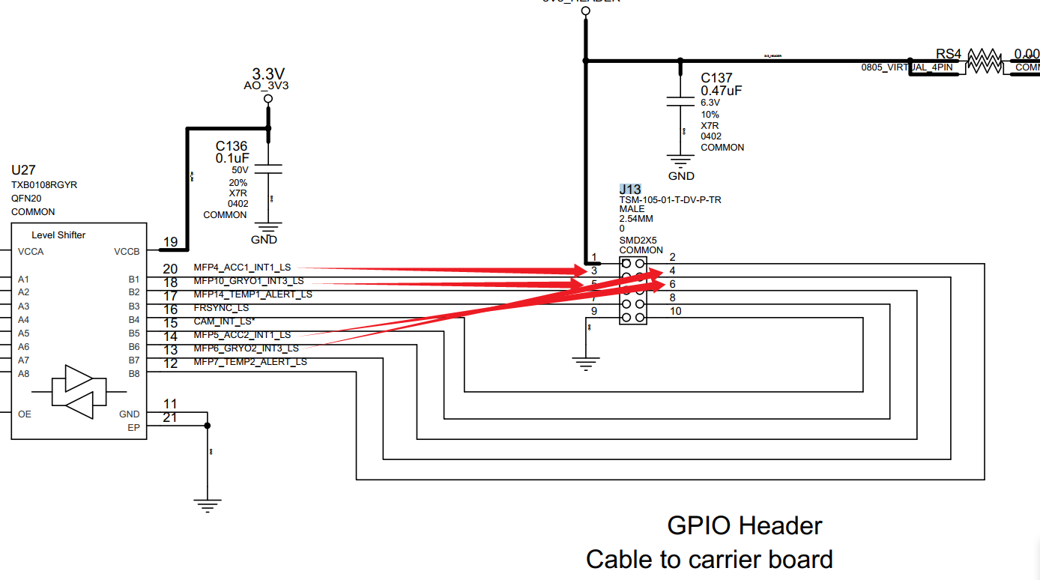

Figure 2: IMU used pins in E3653-A03 adapter board’s J13 header is shown in this picture.

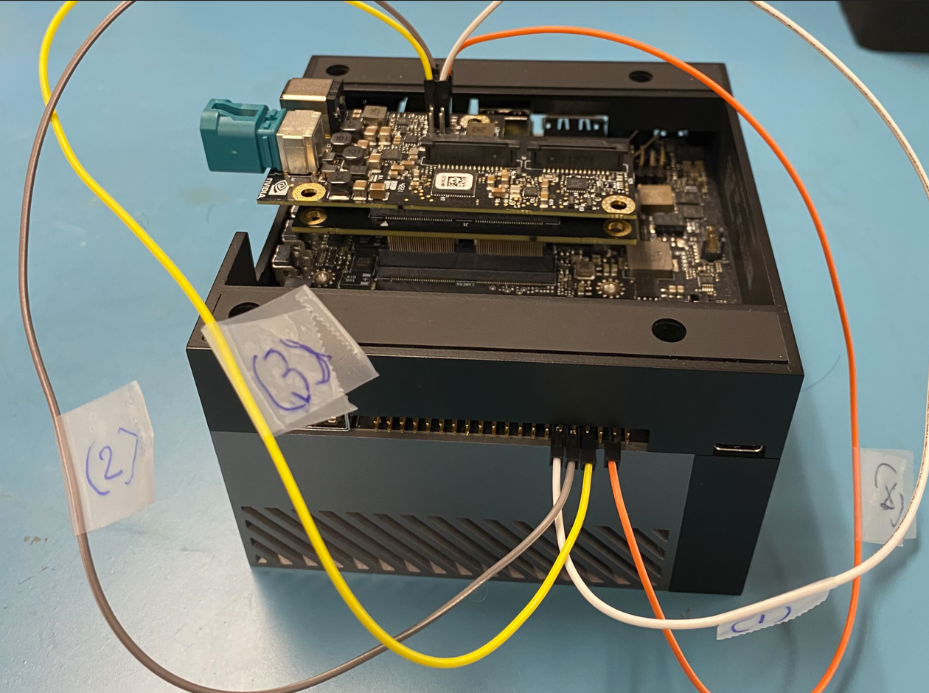

Figure 3: This picture shows the physical IMU test wire connections on the Jetson AGX Orin system with E3653-A03 adapter board.

The detail explanation for wire 1, 2, 3, 4 connections are described in the following image (Figure 4).

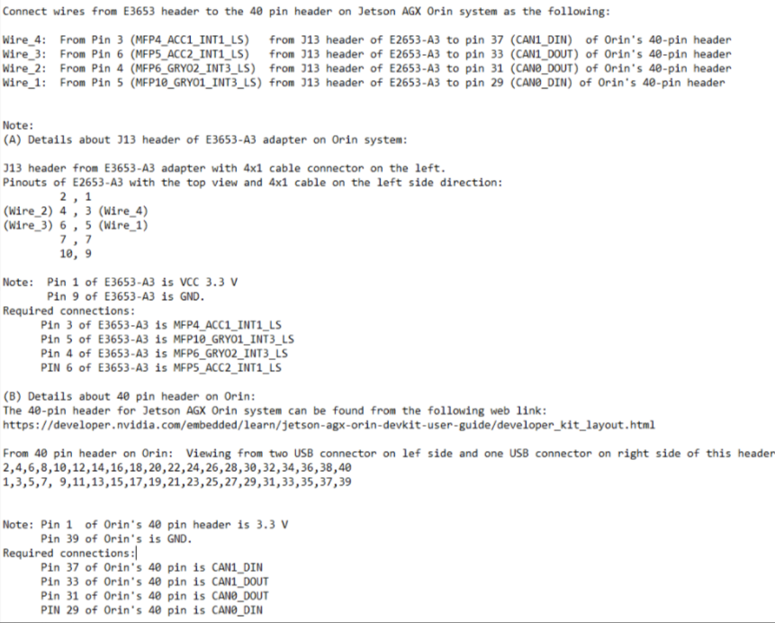

Figure 4: Above picture shows the details of the wire connections for IMU test on Jetson AGX Orin system with E3653-A03 adapter board,

|  |
| --- |
| 3D Depth Support |
| The two LI-AR0234CS-STEREO-GMSL2-30 camera can also stream mono color 3-D Depth images as in using the “vpi_demo_stereo” application.  Note 1:  Make sure the following commands are issued before in Orin system without power cycle.  sudo insmod max96712.ko  sudo insmod nv_ar0234.ko  sudo insmod bmi088.ko  Note 2:  We assumed that you already installed “HOST COMPONETS” that contains the “Computer Vision” (VPI components) from Note ½ section of this driver.  First install the “vpi_demo” samples using the following Linux commands:  cd /opt/nvidia/vpi2/bin  ./run_demo.sh  ./vpi_install_sample.sh  Next, from the :/opt/nvidia/vpi2/bin” directory in Orin system, issue the following Linux command to launch Nvidia’s vpi_demo_stereo application window.  cd /opt/nvidia/vpi2/bin  ./vpi_demo_stereo  Finally, select the menu option “Window” -> “Camera” and choose “HAWK1” and then “HAWK2” to display the 3D depth images that are captured from the two LI-AR0234CS-STEREO-GMSL2-30 cameras as shown in figure 5 and 6. |

Figure 5: The “vpi_demo_stereo” application window’s selections for using two HAWK1 and HAWK2 cameras to stream 3D depth images from two LI-AR0234CS-STEREO-GMSL2-30 cameras.

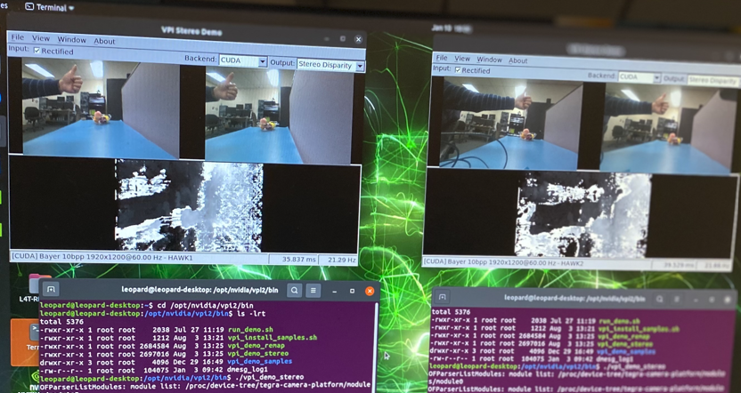

Figure 6: Mono color 3D depth images displayed from two Hawk cameras (LI-AR0234CS-STEREO-GMSL2-30) using the “vpi_demo_stereo” application.